WILCO FFA HONORED AT STATE CONVENTION
SPRINGFIELD – Members of the WILCO FFA Chapter attended the 89th annual Illinois State FFA Convention on June 13-15 along with 3,500 other FFA members, advisors, and guests.
“Maximize” was the theme of the three-day event which recognizes annual successes of Illinois FFA members, elects the major state officer team, and celebrates agriculture. Students at the convention were greeted with activities including an exhibit hall featuring colleges and businesses, an evening dance and talent show, and an opportunity to engage in the history of Illinois’ capital city. The convention program featured keynote presentations by National FFA Central Region Vice President Valerie Earley, of Minn., and Hoan Do, a former contestant on “American Ninja Warrior,” student success coach, and motivational speaker.
During the convention, the following award was presented to the WILCO FFA chapter:
Rechartered Chapter: The chapter was recognized for rechartering the FFA program in the past year. Wilco FFA rejoins the community of Illinois FFA chapters, which currently number 321.
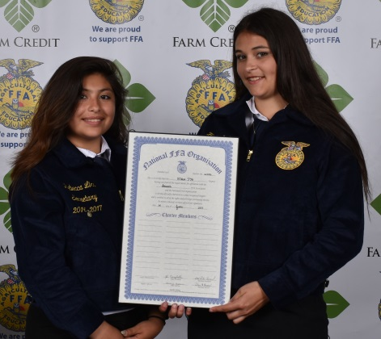
Pictured above (from L to R) in Photo: Rebecca Lira, Haley Costain
###

About Illinois Association FFA
The Illinois Association FFA is part of the National FFA Organization, formerly known as the Future Farmers of America. More than 17,500 students are enrolled in 321 different FFA chapters in the State of Illinois. FFA is a national youth organization of 649,355 student members with a mission of making a positive difference in the lives of students by developing their potential for premier leadership, personal growth, and career success through agricultural education. Visit www.illinoisffa.org for more information.

About the Illinois Foundation FFA
Illinois Foundation FFA engages individuals, industry, education, government, and foundations in securing funds to support quality agricultural education and FFA programs in Illinois, including providing awards at the State FFA Convention. To learn more and become involved, visit www.illinoisffafoundation.org.

For more information, contact:
Illinois FFA Center | 3221 Northfield Drive | Springfield, IL 62702
217-753-3328 | www.illinoisffa.org

