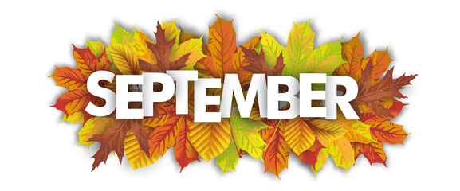

Teacher Contact Info:  Nicole Kinzer  nkinzer@wilcoacc.org  Scott Dudgeon  sdudgeon@wilcoacc.org  School phone & website:  (815) 838-6941  www.wilco.k12.il.us  Topics:  First time in the lab this past month students learned how to make sugar cookies and properly use various icing techniques:  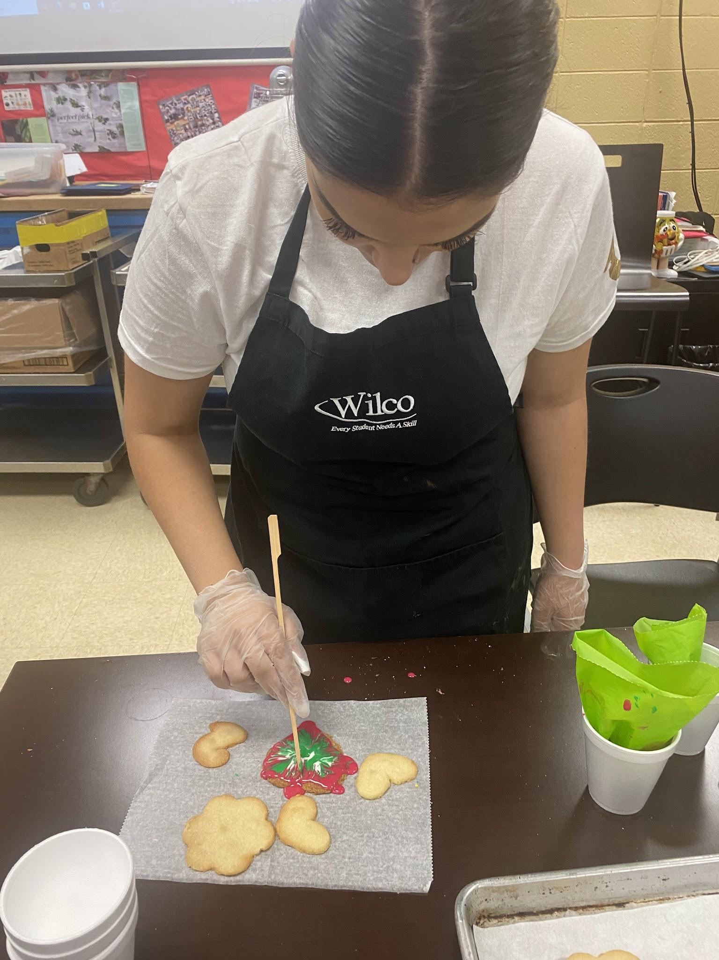  Students are also learning the history and cuisine of Culinary Arts.  Currently the students are working on types of cuisine: here are some examples  Grande (Haute): Gougères (cheese puffs)  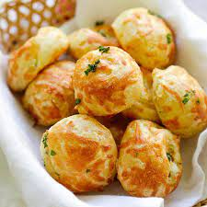  Classical: Coq Au Vin(chicken cooked in wine)  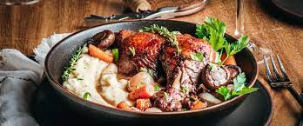  Avant- Garde: mixed green salad with candied walnuts, with balsamic vinaigrette in a crispy Parmesan bowl.  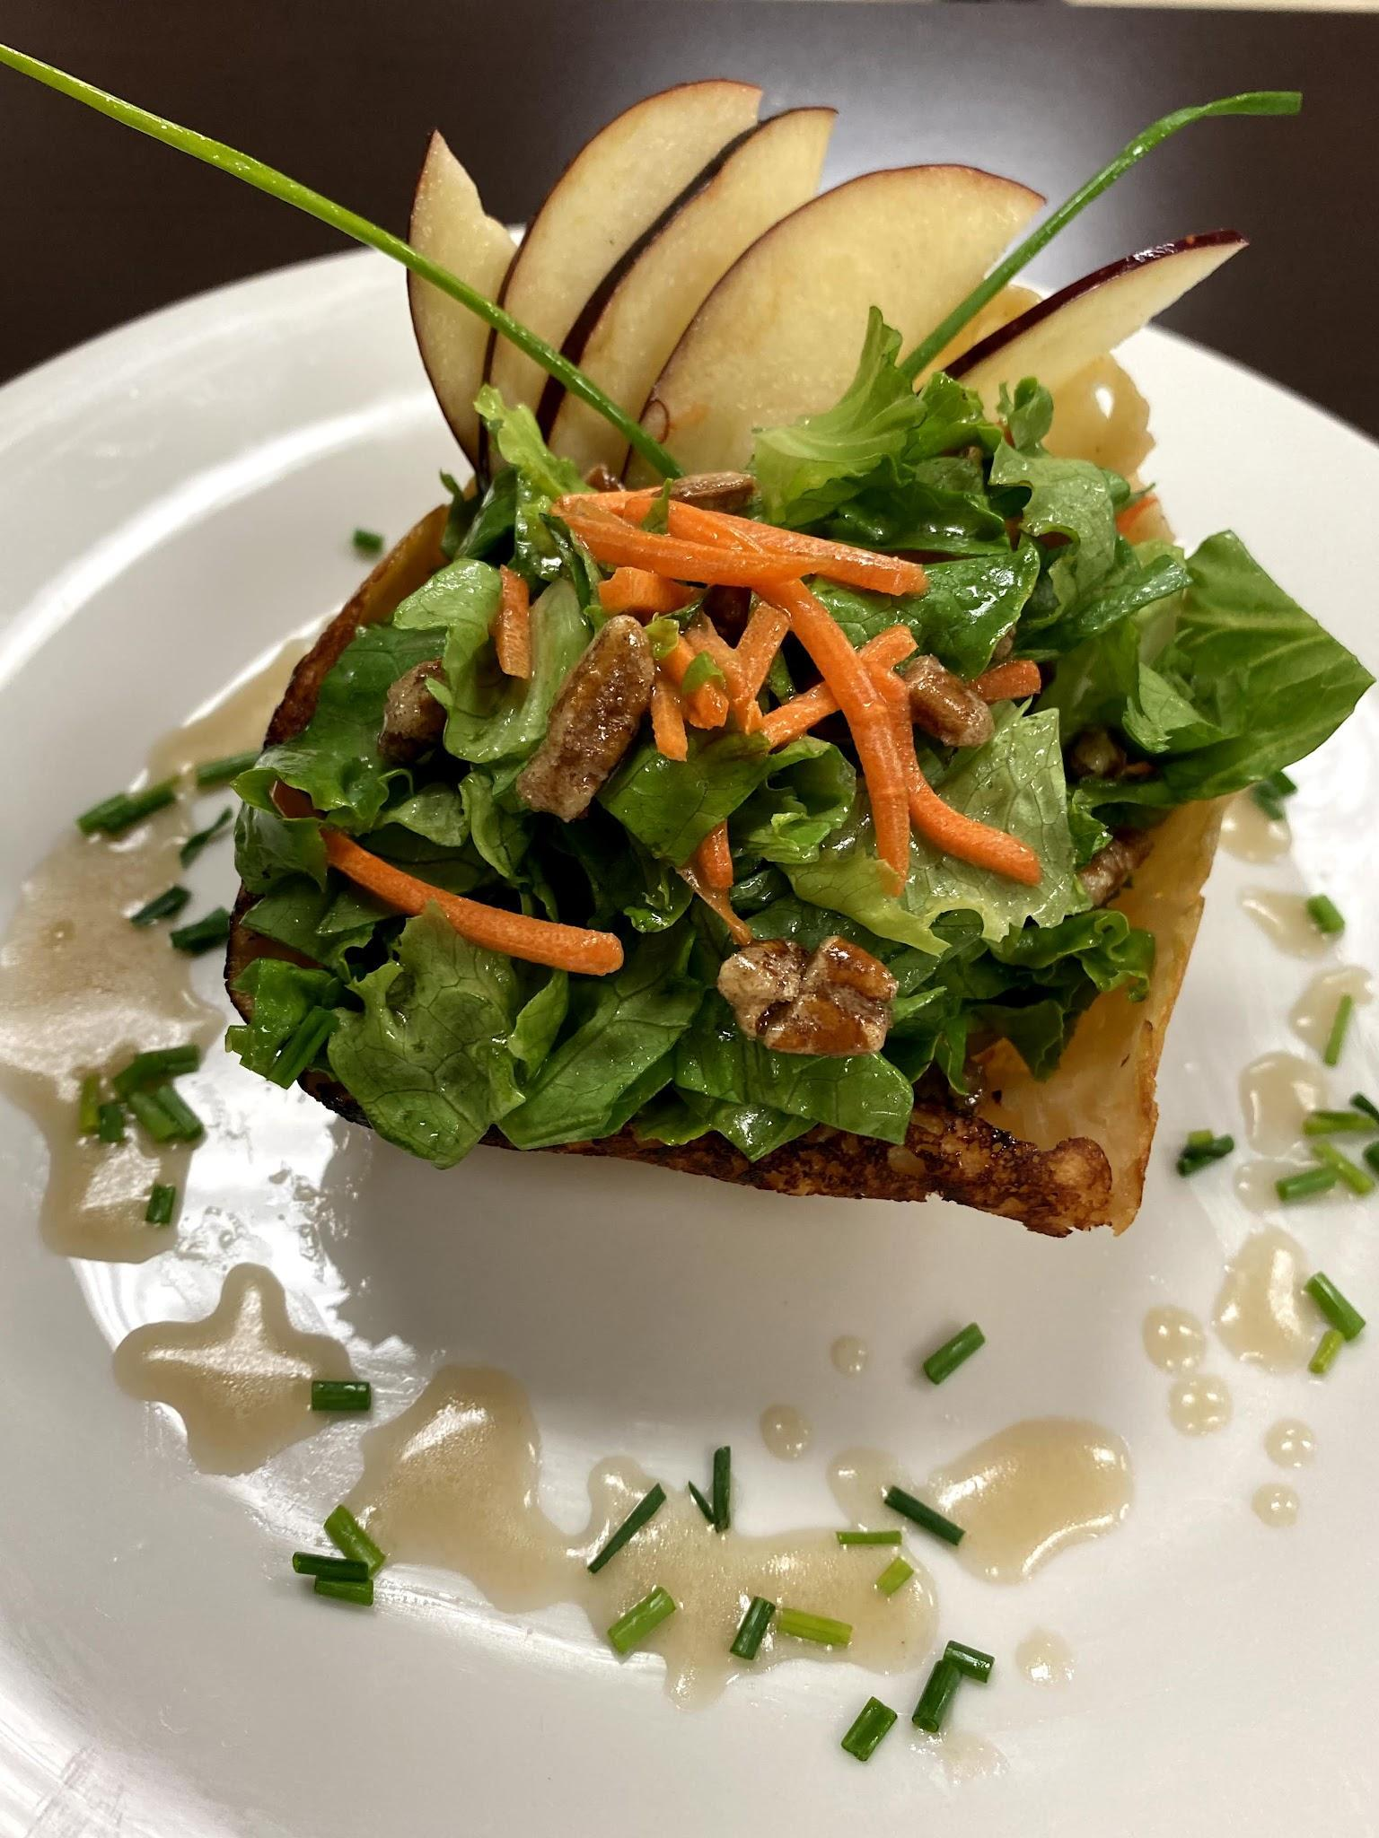  Nouvelle: a dish that is cooked quickly, seasoned lightly, and presented artistically.  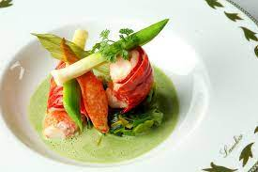  New American: Any ingredient that grows native to the American region: such as crawfish etouffee  from Louisiana 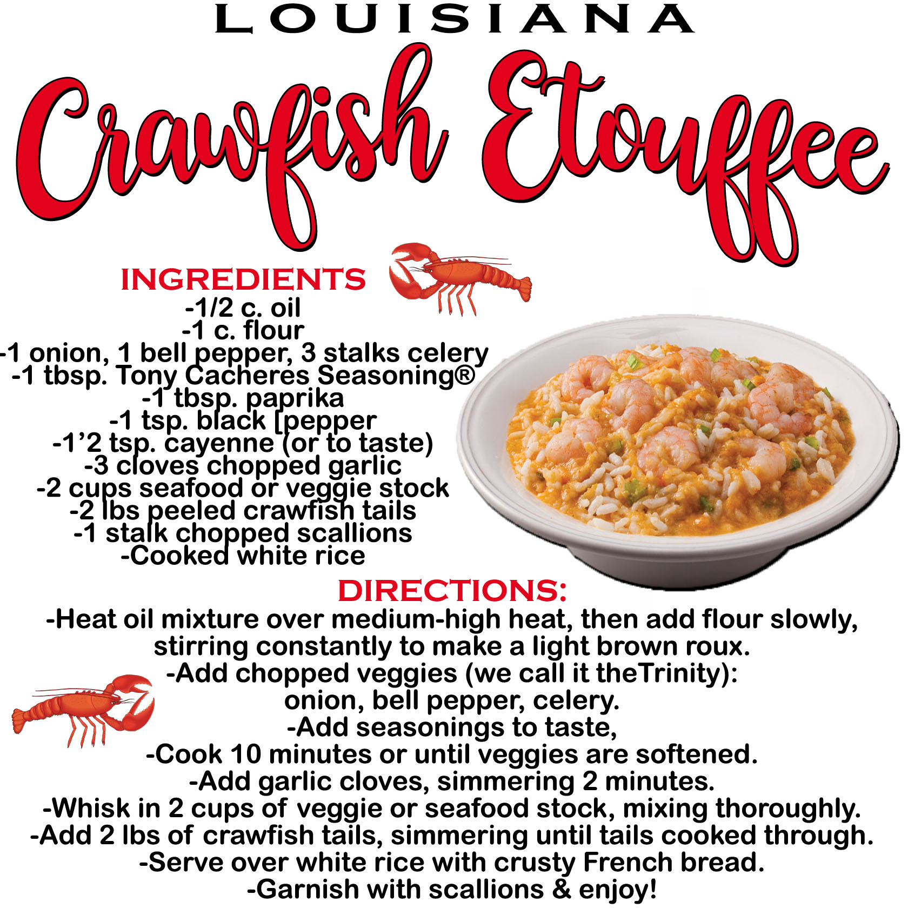  - Sanitation Managers test $36 payable to Wilco  - Allergen test online www.servsafe.com $22  https://wilco.revtrak.net  After learning this topic students will transition into CA 106 Sanitation class for the next 6 weeks | 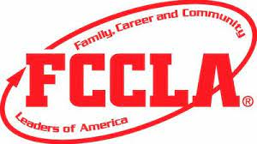  FCCLA is a Wilco Culinary student organization.  Students do not have to compete to join FCCLA.  We are a student organization that serves our community! Students are encouraged to compete in FCCLA competitions so they will have the ability to earn scholarships for college.  To join FCCLA there is a $14 fee. This can be paid with check, cash, card over phone or through our online payment system: https://wilco.revtrak.net  Once payments are received we will print out membership cards for each student that allows them to get discounts at some stores related to the industry.  On the competition team students will create projects and present them at regionals later this year.  Culinary Competitions include:  - Culinary Arts  - Baking and Pastry  - Hospitality  - Food Innovations  - Fondant Cakes  - Frosted Cakes  - Relish Tray  - Salads  - Food Truck  - Nutrition  - Sports Nutrition  If the students place Gold at regionals in February, they will then advance to State competitions. State takes place in Springfield in April. (Culinary and baking and pastry compete in Glen Ellyn for state.)  If they place gold at State for  star events only, then they can compete at Nationals.  Our National conference this year takes place in Seattle, WA at the end of June 2024!  https://fcclainc.org/  http://ilfccla.org/  FCCLA Community Events:  September 21: Cake Pop and Slushie fundraiser at Wilco Open House.  September 30th:Wilco students can participate in the Plainfield Homecoming parade.  October 20th  Trunk or Treat at Deer Crossing Park, Romeoville  November:(TBD)  Food pantry  soup kitchen  December:(TBD)  Childrens clothes donations  and food pantry collection  FCCLA holds fundraisers throughout the year such as:  - AFFY TAPPLES  - CAKE POPS and SLUSHIES AT OPEN HOUSE  - JAMS AND JELLIES  - HOLIDAY CANDLE SALES  - WORLD'S FINEST CHOCOLATE  All proceeds go to our students to help them to afford competing to earn scholarships!  If you have a community event you would like us to join, please email nkinzer@wilcoacc.org  - | Important Dates:  THURSDAY SEPT 21  - OPEN HOUSE  6PM-8PM  Wilco Area Career Center  500 Wilco blvd.  Romeoville, IL 60446  EVERYONE IS INVITED OPEN TO THE PUBLIC  CULINARYSTUDENTS WILL BE SERVING TREATS!!!  FCCLA FUNDRAISER  - CAKE POPS $2  - SLUSHIES $1 FLAVORS:PINA COLADA AND BLUE RASPBERRY  TO JOIN YOUR STUDENTS CLASSROOM  classroom.google.com  1ST SESSION  CA 105 Culinary Arts Classroom  h5xzkze  CA 106 Sanitation classroom  gce7rep  2nd SESSION  CA 105 Culinary Arts Classroom  32zul6b  CA 106 Sanitation Classroom  5i7obpb  3rd SESSION  CA 105 Culinary Arts Classroom  sahkm5l  CA 106 Sanitation Classroom  reezqtz  2ND YEAR STUDENTS  classroom.google.com  2ND YEAR CULINARY CLASSROOM  m5z5sll  2ND YEAR BUS110 CLASSROOM  44xk6yk  FCCLA CLASSROOM  classroom.google.com  FCCLA CLASSROOM FOR ALL STUDENTS  a7w6ps4  